Types of Association – One-to-Many

📌 Definition:
# Source: AI Source: Provided by: [Data Path: Persons Table -> ID Column: 1, Name_En Column: Motasem Essam] -> From: [Chatgpt (GPT‑5 Mini)] on [12/9/2025]
One-to-Many association is a relationship where one object is related to many other objects, but those objects are still independent.

🧠 Simple idea:
# Source: AI Source: Provided by: [Data Path: Persons Table -> ID Column: 1, Name_En Column: Motasem Essam] -> From: [Chatgpt (GPT‑5 Mini)] on [12/9/2025]
One-to-Many = “1 → many” 👨‍🏫➡️👨‍🎓👨‍🎓👨‍🎓

🔍 Key characteristics:
# Source: AI Source: Provided by: [Data Path: Persons Table -> ID Column: 1, Name_En Column: Motasem Essam] -> From: [Chatgpt (GPT‑5 Mini)] on [12/9/2025]
- 🔗 One object → multiple objects
- 🧩 Each child object belongs to one parent (in this direction)
- 🔄 Objects can exist independently
- ⚙️ Very common in real-world systems

📌 Real-world examples:
# Source: AI Source: Provided by: [Data Path: Persons Table -> ID Column: 1, Name_En Column: Motasem Essam] -> From: [Chatgpt (GPT‑5 Mini)] on [12/9/2025]
- 👨‍🏫 Teacher → Students
- 🏫 Class → Students
- 🏢 Company → Employees
- 🛒 Order → Items

📌 Example (Java-style):
# Source: AI Source: Provided by: [Data Path: Persons Table -> ID Column: 1, Name_En Column: Motasem Essam] -> From: [Chatgpt (GPT‑5 Mini)] on [12/9/2025]
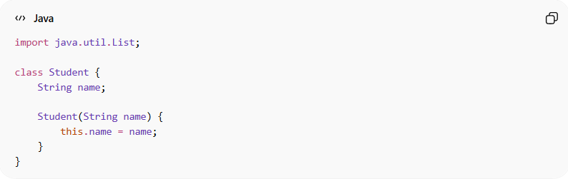
import java.util.List;

class Student {
String name;

Student(String name) {
this.name = name;
}
}
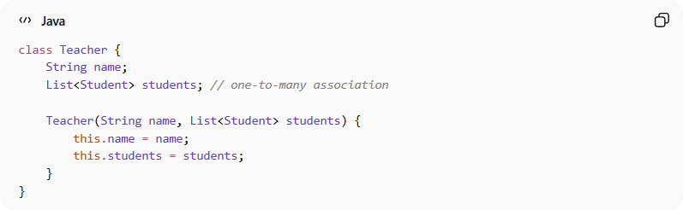
class Teacher {
String name;
List<Student> students; // one-to-many association

Teacher(String name, List<Student> students) {
this.name = name;
this.students = students;
}
}

Usage:
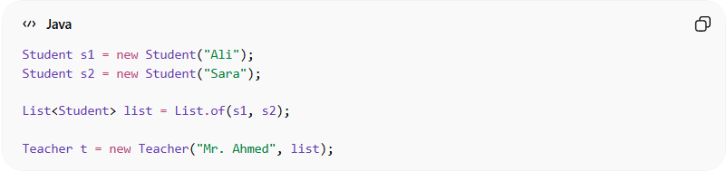
Student s1 = new Student("Ali");
Student s2 = new Student("Sara");

List<Student> list = List.of(s1, s2);

Teacher t = new Teacher("Mr. Ahmed", list);
👉 One teacher teaches many students.

🔄 Relationship diagram:
# Source: AI Source: Provided by: [Data Path: Persons Table -> ID Column: 1, Name_En Column: Motasem Essam] -> From: [Chatgpt (GPT‑5 Mini)] on [12/9/2025]
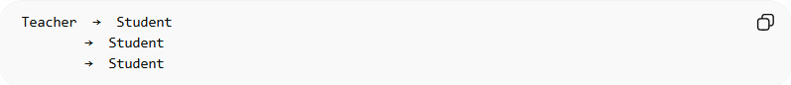
Teacher → Student
→ Student
→ Student

🎯 Why it is important:
# Source: AI Source: Provided by: [Data Path: Persons Table -> ID Column: 1, Name_En Column: Motasem Essam] -> From: [Chatgpt (GPT‑5 Mini)] on [12/9/2025]
- 🧩 Models real-world group relationships
- 🔄 Supports scalable system design
- ⚙️ Common in databases (1:N relationships)
- 🧠 Improves data organization

🎯 Summary:
# Source: AI Source: Provided by: [Data Path: Persons Table -> ID Column: 1, Name_En Column: Motasem Essam] -> From: [Chatgpt (GPT‑5 Mini)] on [12/9/2025]
One-to-Many association means one object is connected to multiple objects, while each of those objects is associated with only that one parent.

